Sales Potential Analysis
Evaluating the Sales Power of Your Employees

Focus | - You want to know how good your sales people really are and you need to drive the motivation and performance of your go-to-market organisation.  - You feel that your sales force has some hidden potentials - and challenges - that are not easy to be specified. Nevertheless, you want to take action.  - Our field-tested and scientifically proven, web-based analysis system will help you developing your sales teams towards performance excellence.  - The assessment will highlight the individual strengths and areas where further growth is possible and necessary for maximum sales performance.  - The assessment provides clear recommendations e.g. for coaching and development of individuals and sales teams.  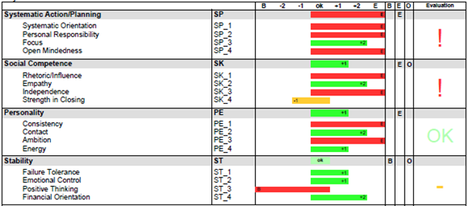
Benefits | - Leveraging existing potentials  - Comprehensive evaluation of entire sales teams  - Strong motivation of the sales staff  - Specific measures to strengthen individual competences  - Defined actions to cope with individual challenges  - Identification of opportunities to sell more and better  - Fast and cost effective
Content | Main factors are systematic action and planning, social competence, personality and stability This includes focus, personal responsibility, strength in closing, energy, and failure tolerance.
Target Group | All employees and managers with regular customer contact in sales, marketing, business development or service who want to achieve better results while wasting less energy.
Price | Depending on group size. Please contact us.

